Experiment 3

Bash Shell Scripting

Done By: Rohit Karunakarn
Date of Submission: 31-05-2021

Program 1: Write a shell script program to display the name of the current working directory and date

#! /bin/bash

echo -e "Working Directory: $(pwd)\nDate: $(date)"

Screen shots:
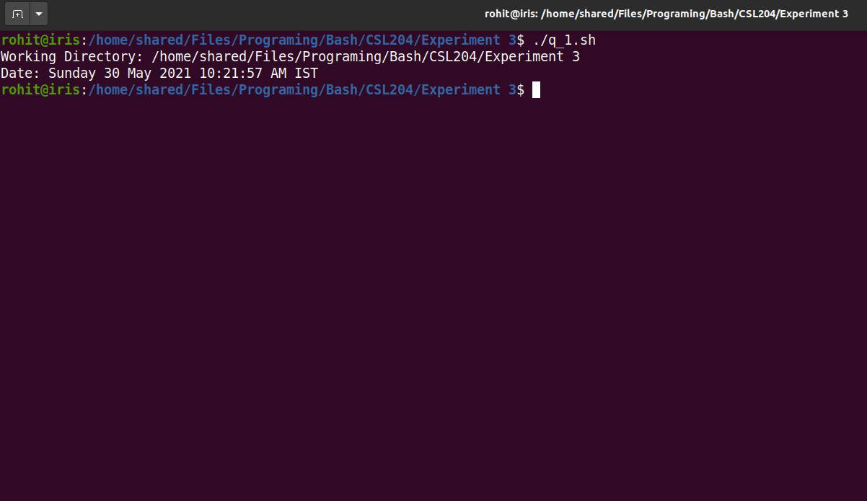

Program 2: Write a shell script program to perform arithmetic operation on two numbers.

#! /bin/bash

echo -n "Enter number 1: "
read a
echo -n "Enter number 2: "
read b
let "c = $a+$b"
echo "Sum = $c"

Screen shots:
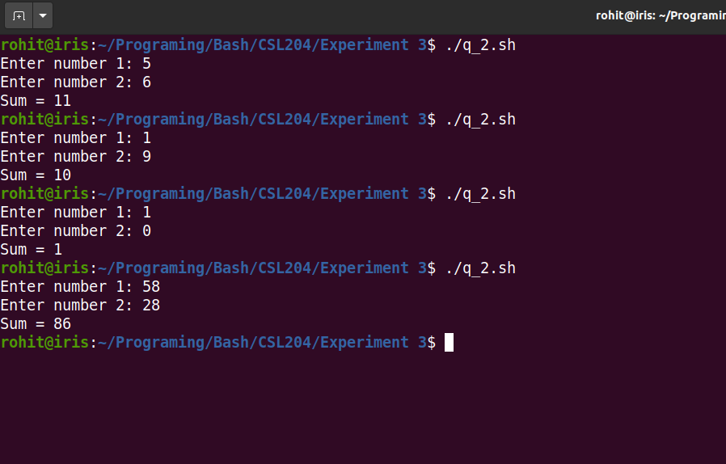

Program 3: Write a shell script program to pass arguments to the program and display the count of arguments and content.

#! /bin/bash

for var in $@
do
echo "${var}"
done

Screen shots:

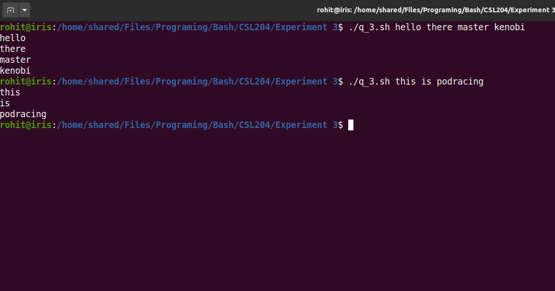

Program 4: Write a shell script program to test whether 3 arguments are being passed to it.

#! /bin/bash

if [ $# -eq 3 ] ; then
echo "Three Arguments are being passed"
else
echo "Three Arguments are not being passed"
fi

Screen shots: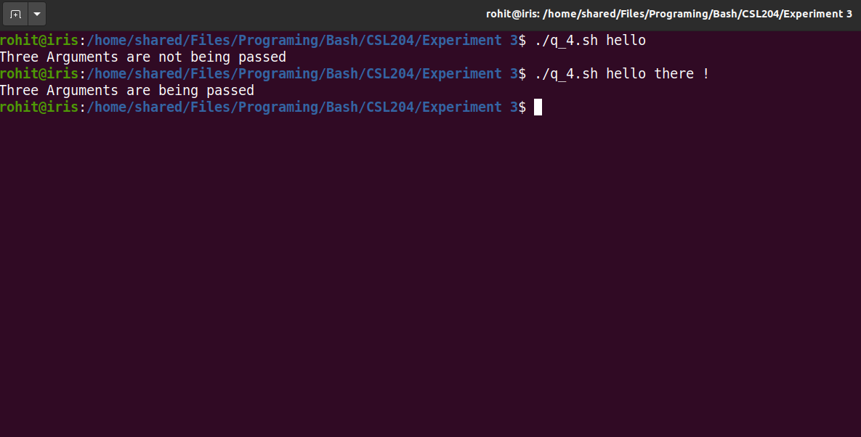

Program 5: Write a shell script program to check whether two strings sent as command line arguments are same or not using test command.

#! /bin/bash

if [ ! $# -eq 2 ] ; then
echo "Two arguments are needed"
else
if [ $1 = $2 ] ; then
echo "The strings are equal"
else
echo "The strings are not equal"
fi
fi

Screen shots: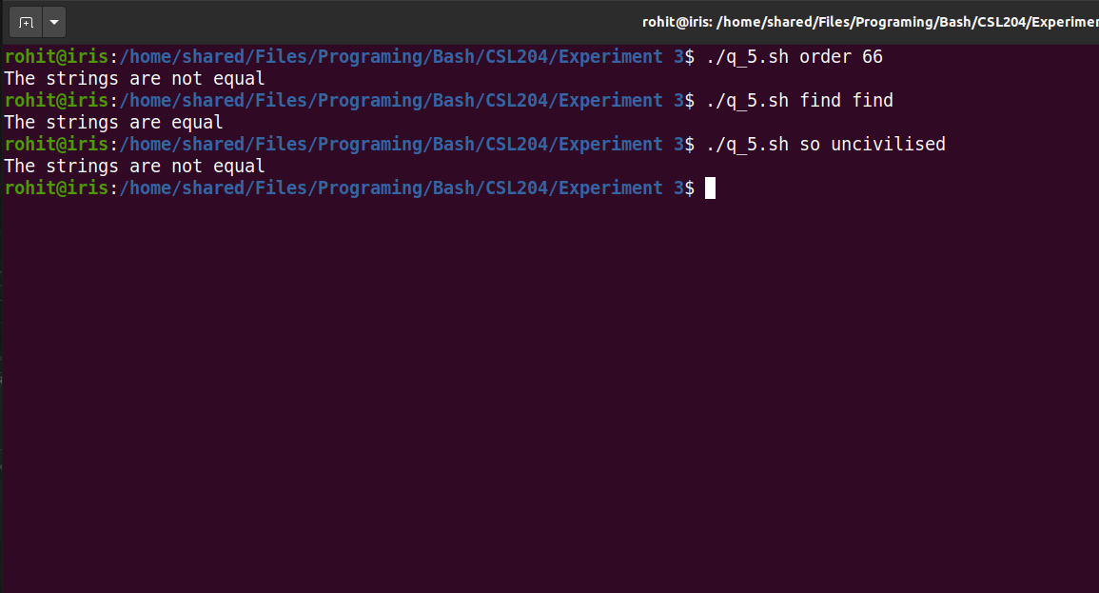

Program 6.a Let argument be a filename. Write a shell script program to check whether the file exists or not.

#! /bin/bash

if [ $# -eq 0 ]
then
echo "Atleast one Argument is required"
else
if [ -f $1 ]; then
echo "File ${1} Exists"
else
echo "File doesnt exist"
fi
fi

Screen shots: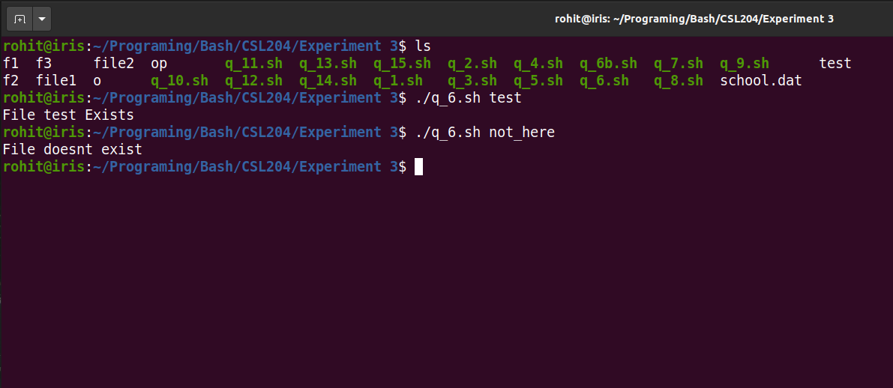

Program 6.b: Modify the above program to rename a filename with another name passed as argument, Also check number of parameters being passed.

#! /bin/bash

if [ $# -lt 2 ]
then
echo "Atleast two Arguments is required"
else
if [ -f $1 ]; then
mv $1 $2
echo "$1 renamed to $2"
else
echo "File '$1' doesnt exist"
fi
fi

Screen shots: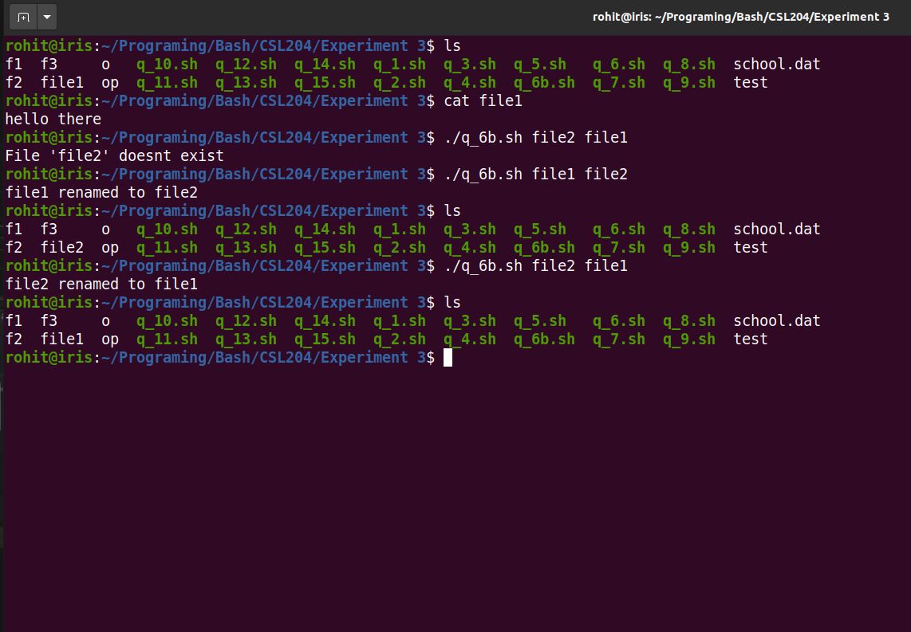

Program 7: Write a shell script program to test whether a string is present in a file or not

#! /bin/bash

if [ $# -lt 2 ]
then
echo "Atleast two Argument is required"
echo "./q_7.sh [file] [string to be searched]"
else
if [ -f $1 ]; then
found=$(grep $2 $1)
if [ -n "$found" ]
then
echo "The string $2 exists in the file"
else
echo "The string $2 is not in the file"
fi
else
echo "File doesnt exist"
fi
fi

Screen shots: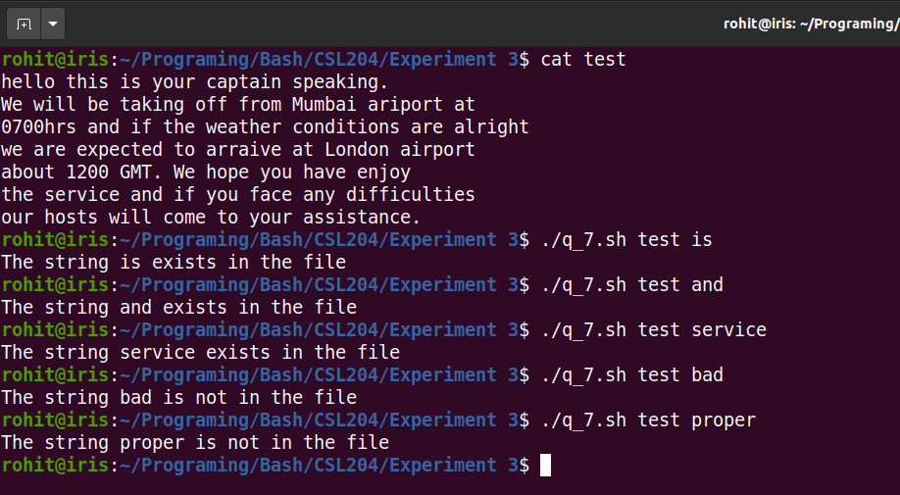

Program 8: Write a shell script program to copy content of file1 to file 2. If file2 exists then append the content of file1 to its original content.
#! /bin/bash

if [ $# -lt 2 ]
then
echo "At least two arguments required"
echo "$0 file1 file2"
else
if [ -f $2 ]; then
cat $1 >> $2
else
cat $1 > $2
fi
fi

Screen shots: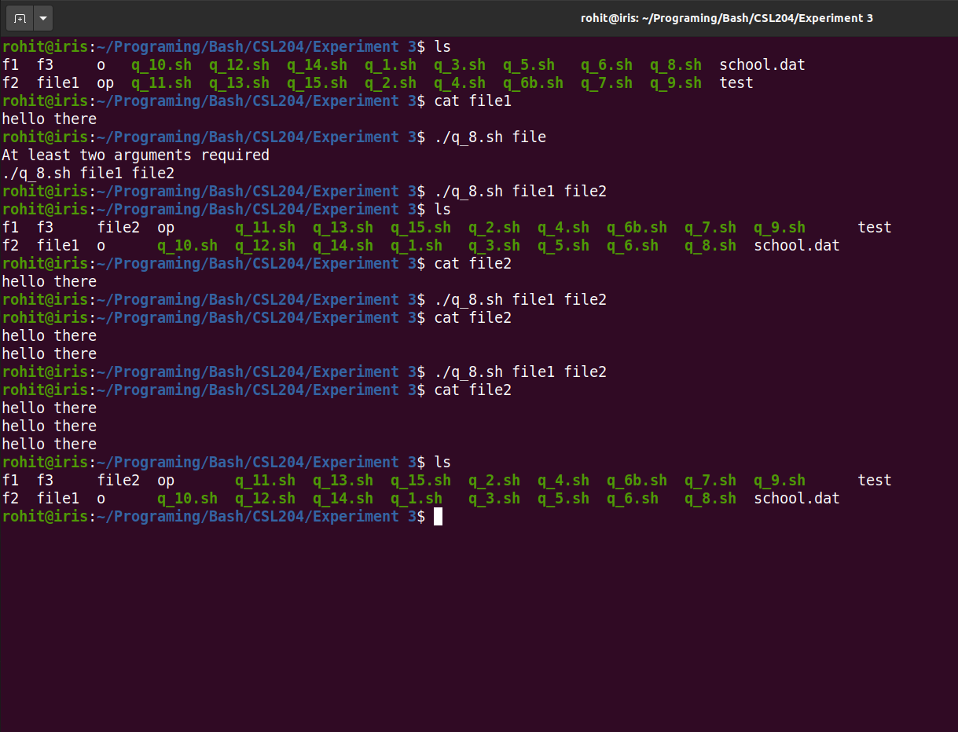

Program 9: Write a shell script program that take first 10 lines from first file and rest 10lines from second file and move them in a third file. The filename will be sent as command line arguments.

#! /bin/bash

if [ $# -lt 3 ]
then
echo "Enter three file names"
else
echo -ne "" > $3

let i=0
while IFS='\n' read -r line
do
if [ $i -eq 10 ]
then
break
fi
echo $line >> "$3"
let "i=$i+1"
done < $1

let i=0
while IFS='\n' read -r line
do
if [ $i -eq 10 ]
then
break
fi
echo $line >> "$3"
let "i=$i+1"
done < $2

fi

Screen shots: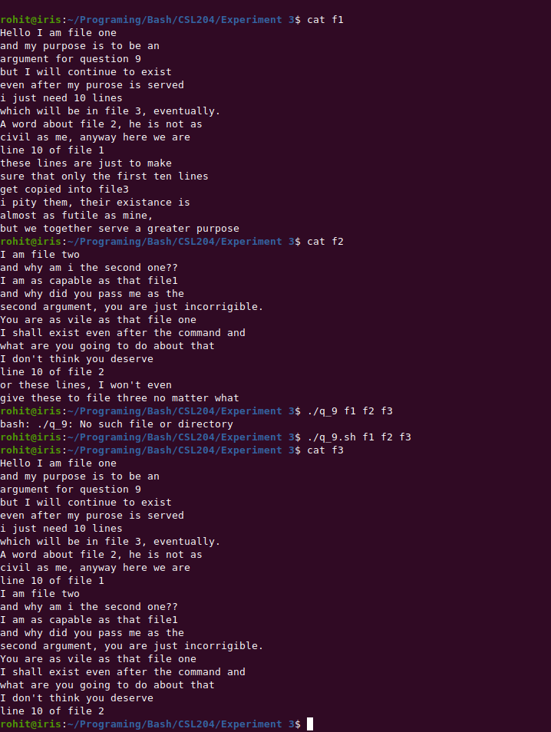
Program 10: Write a shell script program to show number of files in the current directory beginning with a specified character.

#! /bin/bash

echo -n "Enter a Charecter: "
read -r ch

if [ -z "$ch" ]; then
echo "Enter a vaild charecter"
else
echo -ne "Number of files starting with '$ch': "
ls -dF ${ch}* 2>/dev/null | grep -E '[^@|^/]$' | wc -l
fi

Screen shots: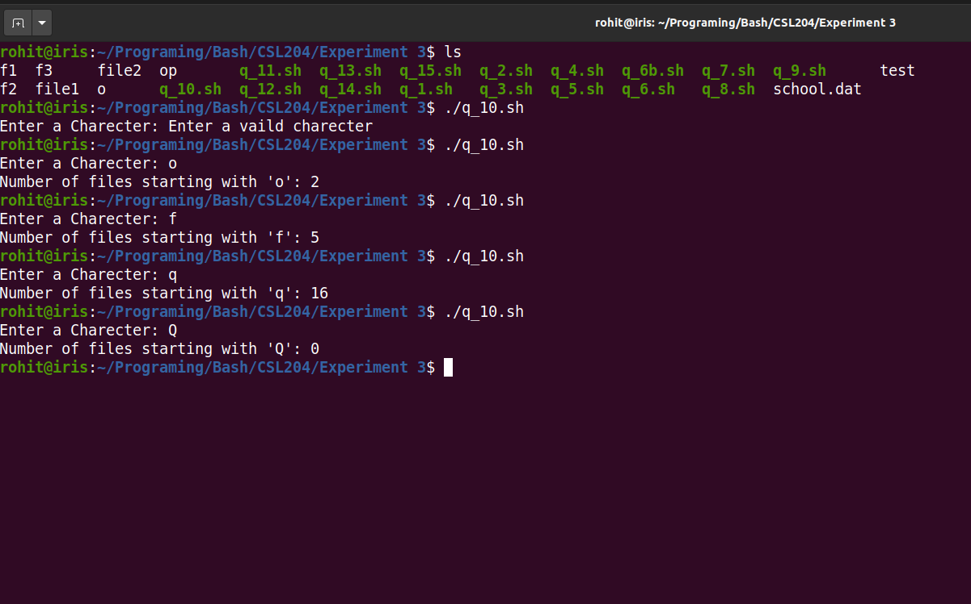

Program 11: Write a shell script program to read a line from a file and store them into another file after converting all the vowels from first file into uppercase.

#! /bin/bash

if [ $# -lt 1 ]; then
echo "Pass two file names as command line argument"
else
read -r l < $1
echo $l | tr "aeiou" "AEIOU" > $2
fi

Screen shots: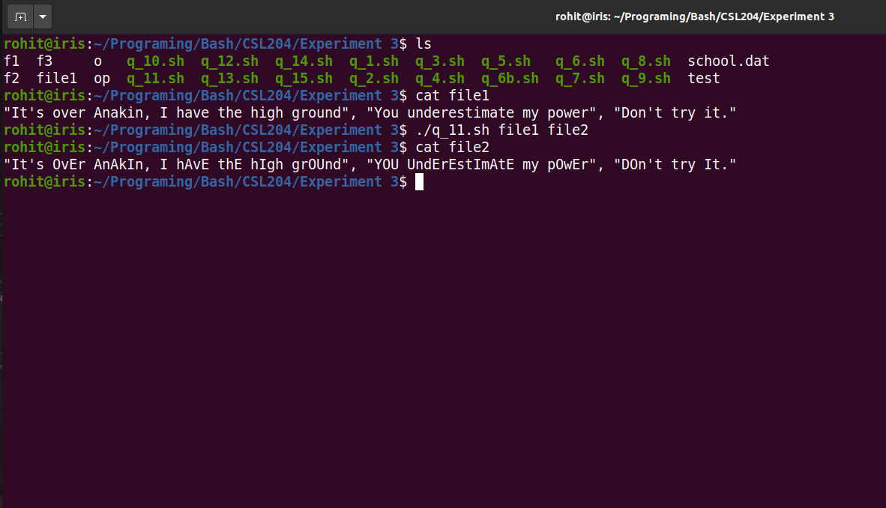

Program 12: Write a shell script program that accept the name of the user and prints the entire name in reverse and also print the length of the entire name

#! /bin/bash

echo -ne "Enter your name: "
read -r l
echo -ne "Name reversed: "
echo -e $l | rev
echo -ne "Number of Charecters: "
echo -e $l | wc -m

Screen shots: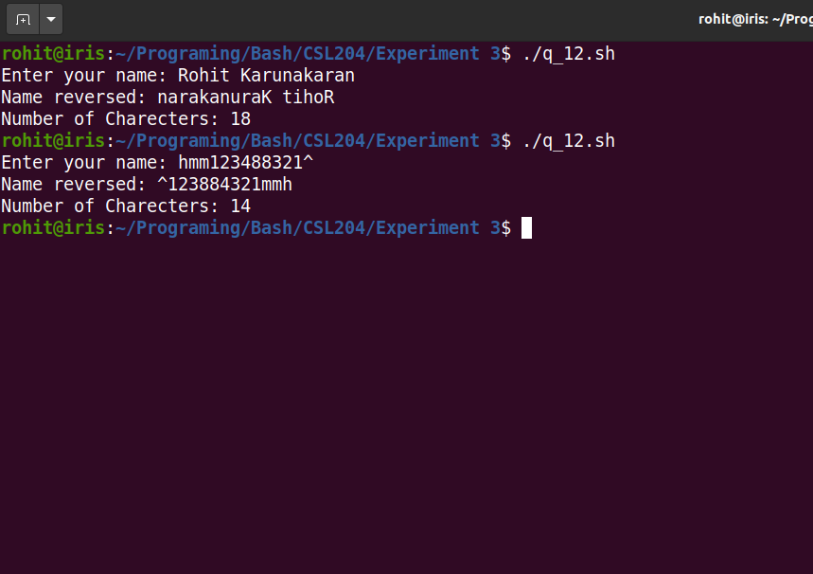

Program 13: Consider a file school.dat with the following fields: roll no, name and marks. Write a shell script program to sort the file in descending order of marks

#! /bin/bash

file="school.dat"

head -n 1 $file
tail -n +2 $file| sort -s -r -nk3

Screen shots: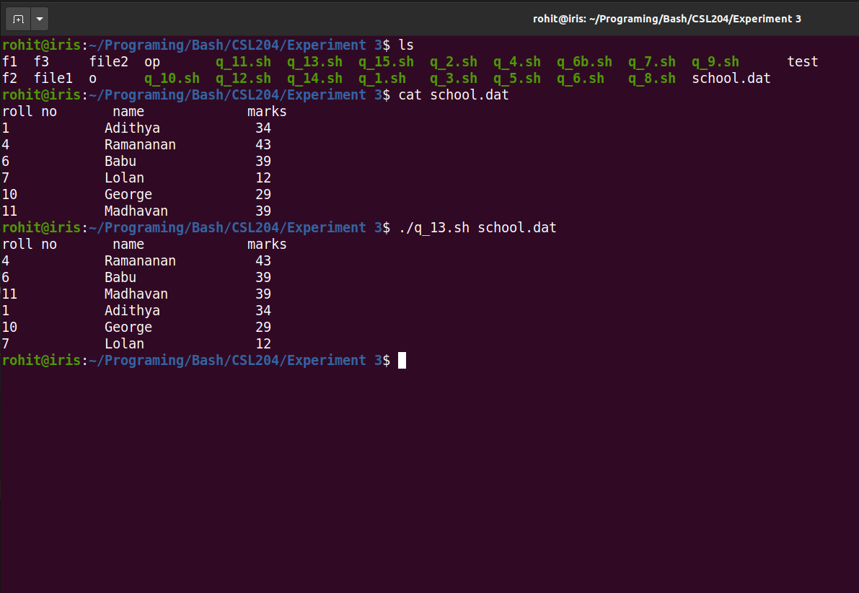

Program 14: Write a shell script program to display sum of first n numbers

#! /bin/bash

echo -n "Enter a number: "
read -r n

#let s="n*(n+1)/2"
let s=0
let i=0

while [ $i -le $n ]
do
let "s=$s+$i"
let "i=$i+1"
done

echo "Sum of numbers from 0 to ${n} : ${s}"

Screen shots: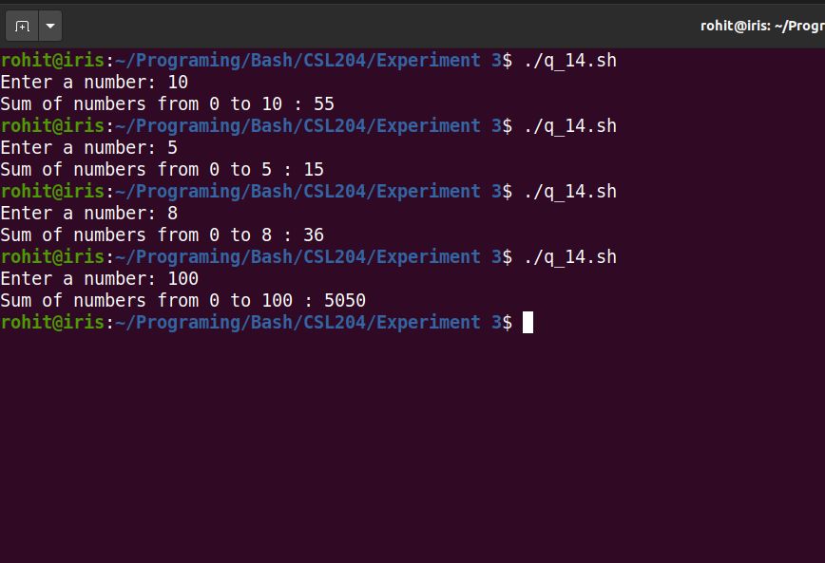

Program 15: Menu driven program to display the day when inputting 1 to 7

#! /bin/bash

echo "----Day Of The Week----"

let RUN=true
while [ $RUN ]
do
echo -n "Enter a number between 1 and 7: "
read -r n

case $n in
1)
echo "Day is Monday";;
2)
echo "Day is Tuesday";;
3)
echo "Day is Wednesday";;
4)
echo "Day is Thursday";;
5)
echo "Day is Friday";;
6)
echo "Day is Saturday";;
7)
echo "Day is Sunday";;
*)
echo "Error: Enter a proper input" 1>&2
esac

echo -ne "Do you want to continue? (n to exit)"
read ch
if [ "$ch" = "n" ] || [ "$ch" = "N" ]; then
exit 0
fi
echo ""

done

Screen shots: